DAILY ONLINE ACTIVITIES SUMMARY
Date: | 27-05-2020 |  |  |  |  | Name: | Apoorva H P
Sem & Sec | VI A |  |  |  |  | USN: | 4AL17CS011
Online Test Summary
Subject |  | SSCD IA Test
Max. Marks |  | 30 |  | Score |  |  | 20
Certification Course Summary
Course | Cloud Foundations
Certificate Provider |  |  | Great Learning |  | Duration |  |  | 4.5hr
Coding Challenges
Problem Statement:
1. Python program to check if a number is palindrome
2. Python program to print all integers that aren't divisible either by 2 or 3 and lie between 1 and 50
Status: Completed
Uploaded the report in GitHub |  |  |  |  | Yes
If yes Repository name |  |  |  |  | https://github.com/ashaapoorva/online-coding-and-certification-course
Uploaded the report in slack |  |  |  |  | Yes

Online test Detail:

Online Certification Details

Modules completed:

-Definitions,Stories & Business Concerns

-Classical Enterprise,Why Cloud & Evolution of Cloud

-Service Models,Abstraction Levels,SPIDERS

-Cloud Attributes,Managed Services & Development Models

-Pricing & Scalling Models

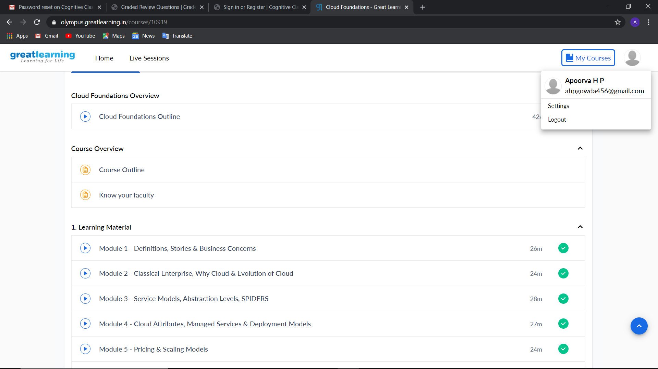

Coding Challenge Details
1. Python program to check if a number is palindrome
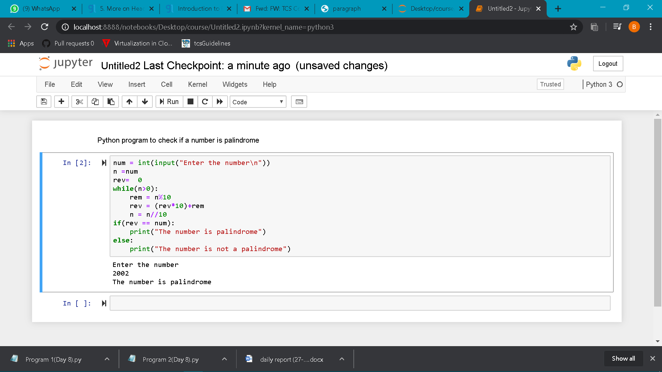
2. . Python program to print all integers that aren't divisible either by 2 or 3 and lie between 1 and 50
